BINDER LABEL: EM 7

TERM: Autumn 1991 – 519

CONTENTS:

- Notes

Problems & Solutions

- Proof of 4 vector identities (#2 ’91)
- Dispersion relation & Vgroup for photon (#4 ’91)
- Show F is a conservative field iff 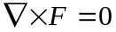 (#6 ’91)
- Analyze distribution 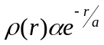 for a single charge (#7 ’91)
- Green’s function for SHO equation: 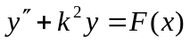 (#11 ’91)
- 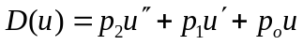. Make μD self-adjoint (#15 ’91)
- Solution of Hypergeometric ODE by series (#18 ’91)
- 2D conducting(grounded) wedge with line-charge present (#19 ’91)
- Put hypergeometric equation into Sturm-Liouville formula (#21 ’91)
- Analyze Helmholtz coil field for homogeneity (#35 ’91)

Exams

- Midterm

    - Non-Columbic electric field: E=[qf(r)]r/r³
    - First order perturbation theory on 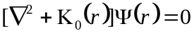
    - Force on a point charge q inside grounded sphere
    - Potential generated by a sphere at Vcosθ

- Final
    - For vacuum EM fields, show: 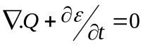
    - Analyze interaction between two small magnets
    - Find (verify) solution to a 2D potential problem
    - Force on Q between conducting planes
    - Analyze repetitive charging a la Van de Graaf
    - A classical model of the electron magnetic moment
    - How a changing B-field generates on E-field

